SAVEETHA SCHOOL OF ENGINEERING
CSA15- CLOUD COMPUTING AND BIG DATA ANALYTICS
LIST OF EXPERIMENT 4
4) Create a simple cloud software application for Car Booking Reservation System using any Cloud Service Provider to demonstrate SaaS.
SOL
AIM:
To design and implement a simple cloud-based Car Booking Reservation System using Zoho Creator and deploy it as a Software as a Service (SaaS) application, demonstrating relational data management via multi-form lookup integrations, multi-user simulation, and remote database transactions through an internet web browser.
PROCEDURE:
- Sign In: Sign in to the Zoho Creator cloud platform using the registered student account credentials.
- Application Shell: Create a completely fresh standalone application by selecting the Create from Scratch option and name it SaaS Experiment 4 Car Booking.
- Form 1 (Customers Table): Design the first data entry form named Customers, adding a Name field labeled Customer Name and a Phone field labeled Contact Number. Publish and save the form setup.
- Form 2 (Cars Table): Design the second data entry form named Cars, adding a Single Line text field labeled Car License Plate and a Drop Down menu labeled Car Model containing vehicle inventory profiles (Suzuki Swift, Hyundai i20, Mahindra Thar). Save the form configuration.
- Form 3 (Bookings Relational Table): Create the third form named Bookings to handle the relational scheduling dependencies:
  - Drag a Lookup Field linking directly to the Customers form, choosing Customer Name as the active display criteria.
  - Drag a second Lookup Field linking directly to the Cars form, choosing Car License Plate as the active display criteria.
  - Add a Date field labeled Booking Date and a Number field labeled Rental Duration (Hours) to log transaction variables.
- Report Generation: Automatically configure standalone list view reports for Customers, Cars, and Bookings to enable multi-tenant data indexing, sorting, and administrative record modification via the cloud.
- Deployment & SaaS Access: Click on the blue Access This Application button to securely publish and host the complete car rental portal live onto the Zoho cloud infrastructure.
- Functional Cloud Testing: Verify operational reliability by sequentially inserting 3 unique sample entries into the Customers form, 3 entries into the Cars form, and executing cross-table tracking lookups inside the live Bookings interface.
SNAPSHOTS:
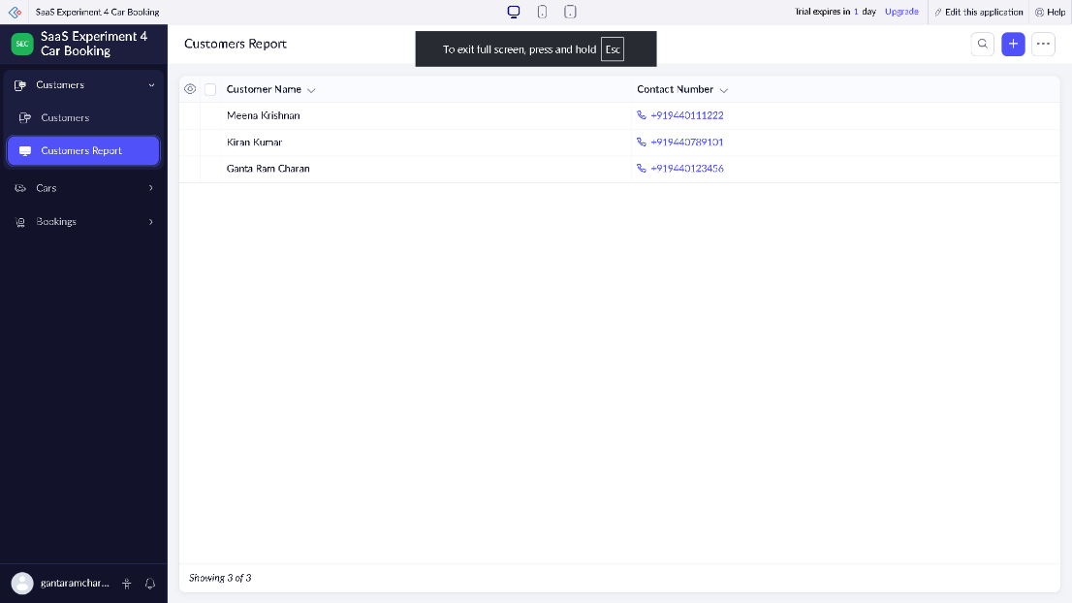

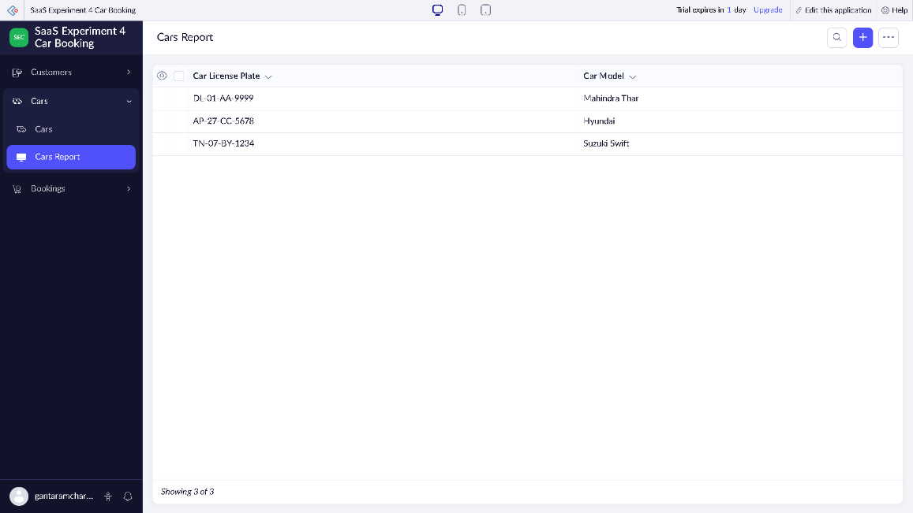

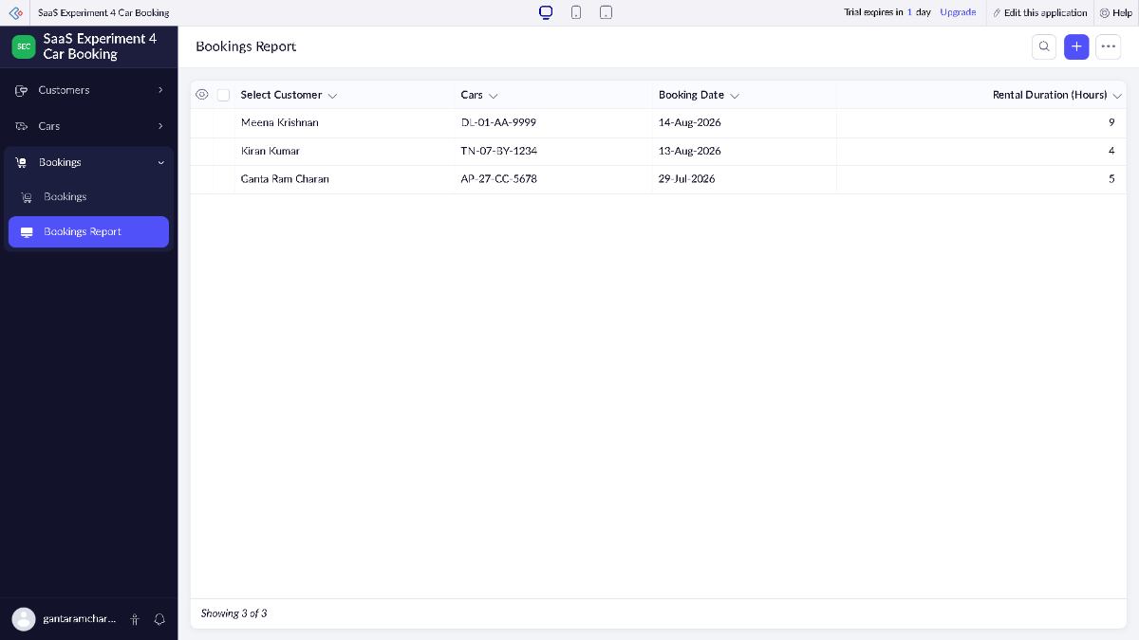
RESULT:
A relational cloud-based Car Booking Reservation System application was successfully developed, integrated, and deployed using the Zoho Creator SaaS development environment. The application operated fluidly over the internet via a standard web browser interface without requiring local desktop infrastructure, effectively validating key multi-tenant Software as a Service (SaaS) deployment concept.

